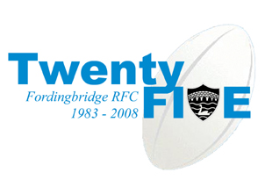

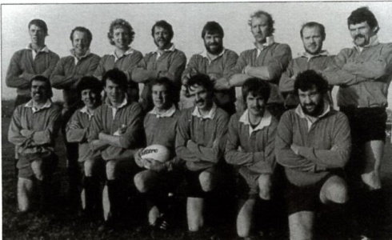

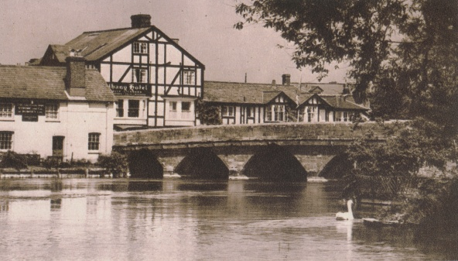

**PREFACE**

**FORDINGBRIDGE** is a rather sleepy, but very friendly town in Hampshire near the borders of Dorset and Wiltshire in the North West corner of the New Forest - 10 miles south of Salisbury and 16 miles north of Bournemouth. The town’s football club, the Turks, is nearly 150 years old but the Rugby club was launched only in the autumn of 1983. This booklet marks the 25th Anniversary.

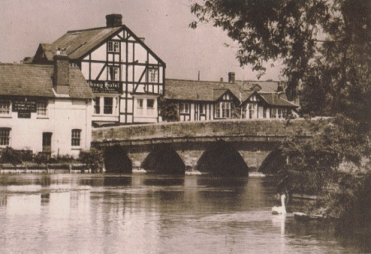It outlines the history of the club....the memorable moments....and the characters. There is a wealth of fascinating photographs from the “Founder” team right through to the present day. We pay tribute to the club’s two senior teams who this season have been champions in both the Hampshire and Dorset & Wilts leagues. We also chart the remarkable development of the mini and junior section which has more than 200 children registered between the ages of seven and 14.

In the picture you can see the central features of Fordingbridge, the Great Bridge and the River Avon. You can also see in the middle, opposite the George Public House, the old Albany Hotel where the Rugby club was formed in 1983. Later in the 1980s the Albany was pulled down but the Rugby club has gone from strength to strength, so much so that in the 2009/10 season the 1st XV will be playing in a London South West League.

Headquarters is now the town’s recreation ground, scene also of a Grand Anniversary Ball held in mid-summer to commemorate the 25 Years of Fordingbridge Rugby club. “By holding the Ball at the Rec we want to support the local community and give something back to the town”, says Club Chairman John Mouland. “Indeed we are indebted to all of our sponsors and not least Guy Deeker of Pains Fireworks for his sponsorship of this booklet”.

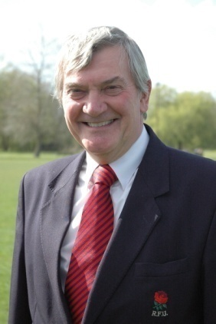**FOREWORD by LeRoy Angel**

**Born in Winchester, LeRoy made some 600 appearances for Winchester and, with 26 caps, was Hampshire’s most capped wing three-quarter. An architect by profession, he became President of Hampshire from 1999-2002 and in the 2005-2006 season he became President of the RFU at Twickenham.**

Before, during and after my season as President of the Rugby Football Union I was privileged to be invited to many clubs throughout the length and breadth of England. It was no surprise that there were a great many similarities between them – a great affection for Rugby Union football and the enjoyment in being part of it. Their driving commitment to the Game whether as a player, match official, coach, or one of the many other administrative roles that are necessary for all clubs to exist and thrive There is also, of course, that special sense of humour which is peculiar to all rugby folk. Having said all this, the truth is also an anomaly - that while Rugby clubs are very similar they are also unique, each in their own way.

So it is with Fordingbridge RFC. Founded in 1983 their home has been the Recreation Ground just on the outskirts of this small town on the western edge of Hampshire’s beautiful New Forest. A friendly club with a strong family identity and a loyal membership which is borne out by the fact that many of the current senior players started at the club as minis or juniors.

Fordingbridge RFC enhances the sporting community in the area not just for adults but also for the young boys and girls who flock to the club for mini and junior rugby activities overseen by qualified, responsible and CRB approved adults, many of them parents of the children. Fordingbridge RFC is a safe environment in which children may learn about Rugby Union football, its skills, sportsmanship and the traditions of the game for which all rugby men and women are justifiably proud and which is admired and respected by everyone.

I have visited the Club from time to time and even spoke at one of the Dinners. It’s just as well they are located on a relatively isolated edge of the town! I have also played several times against the former club captain, now President, Tony O’Connell, in the ‘70s when Tony was a flanker for Trojans and I a wing three-quarter for Winchester so we occasionally came into contact – when he could catch me!! I have known John Trim since about the mid-80s He, and founder member and Chairman, John Mouland are club stalwarts who typify the many hard working administrators who make club rugby in England what it is.

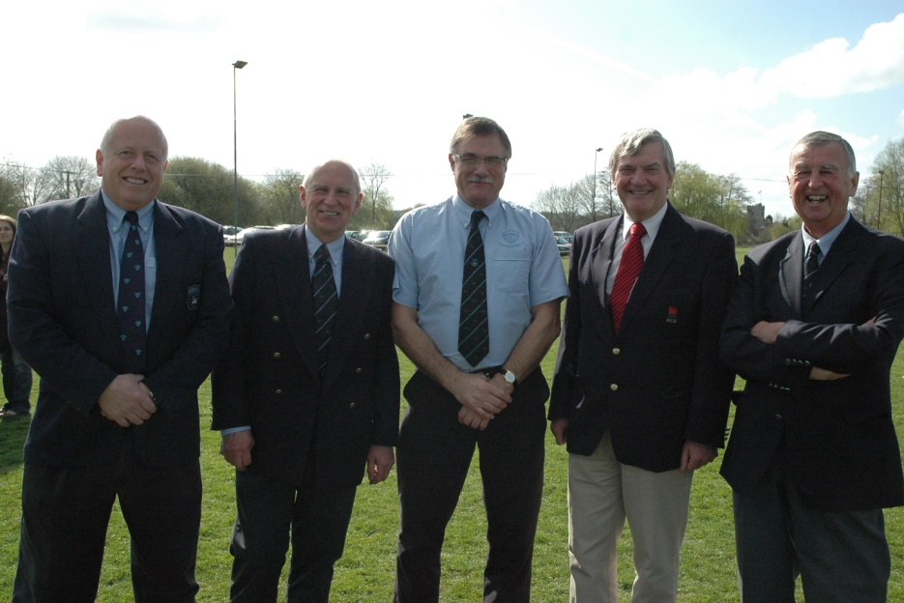

LeRoy Angel, on a visit to Fordingbridge for the 2nd XV fixture against Poole, with (from left to right) John Mouland, John Marsh, Tony O’Connell and Rob Burrows.

It gives me very great pleasure to congratulate Fordingbridge Rugby Football Club on their 25th Anniversary, the first of many similar significant milestones in a continuing existence. I am also delighted to congratulate the club on promotion to a London South West League in the Anniversary season. Well done! Finally, I wish the club an enjoyable, successful and long life.

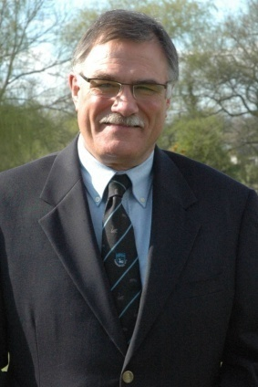**THE PRESIDENT Tony O’Connell**

**Tony “Rocky” O’Connell captained the founding team in November 1983 and is now President of the club. Before he came to Fordingbridge Tony played 325 games for Trojans, and also for the Hampshire county side. He played (vigorously!) at prop, or even No 8. Now, a very active President, he is known for his wit and as a purveyor of advice from the touchline to local referees!**

As a founding member of Fordingbridge RFC back in 1983, I feel very proud to have been associated with the club over the last 25 years and see the growth from a small but ambitious outfit to what we are today – a dynamic organisation with two very successful senior XV’s and an ever increasing junior section which is improving year on year at every age level.

We are privileged to receive sponsorship from many local companies and the number of Vice Presidents is now over 70. We benefit not only from their touchline support but their generous financial contribution provides essential revenue for the running of the club.

The improvements to the clubhouse have made it one of the best on our circuit. It is now a suitable venue for social events throughout the year and has contributed towards the club’s very friendly, family- orientated atmosphere, with VP’s, wives, parents and girlfriends supporting all sections of the club every weekend.

The players are a great group of lads and their commitment and enthusiasm for the game is matched by their terrific team spirit. The juniors are also enjoying huge success, with many youngsters invited to county squad sessions, all age groups achieving outstanding results in local tournaments and, most importantly for the future of the club, providing talented young players who will soon be moving up into the senior sides.

All are going from strength to strength with both senior sides winning their respective leagues and gaining promotion in this anniversary season. Having seen, and been associated with, the remarkable progress we have made over the last 25 years I am honoured to be President of the club at this special time.

FOUNDER TEAM: 1983/84 SEASON

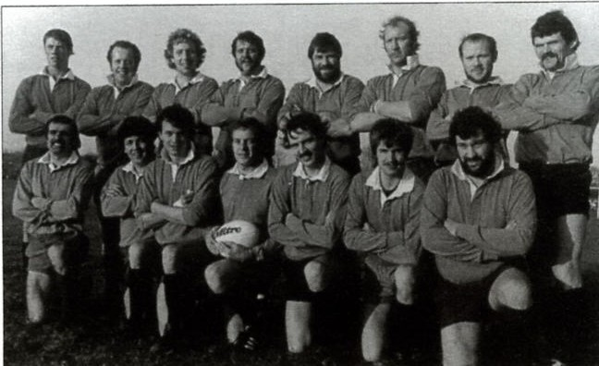

D Park, J Mouland, A Warr, S Godden, T O’Connell, M Mitchell, L Westlake, B Fuller,

M Noke, K Morgan, G Pollard, K Phillpott, R Todd, D Smith, C Scott

Success does bring with it a few problems, one of which is the shortage of playing surfaces. However, I am confident that with our resolve and determination the club will continue to grow and flourish over the next 25 years.

I would like to congratulate all concerned on their efforts, be it on the playing field, in the committee room, on the touchline or just with their presence and support in the clubhouse. You have all helped make Fordingbridge Rugby Club what it is today and should feel justifiably proud. So please, please, keep up the good work and, most of all, **enjoy your rugby!**

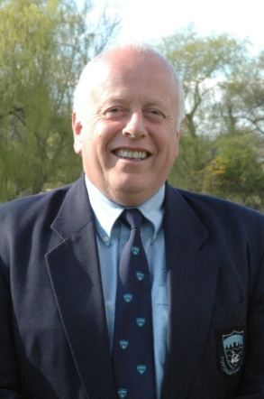**HOW IT ALL BEGAN John Mouland**

**John has been Chairman of the club since 1997. He is always the “life and soul” of the party and it is no surprise that he has been Chairman of the committee organising the Grand Ball to celebrate the club’s Silver Jubilee. John has been a prominent player since he was in the founding team 25 years ago. Here he traces the history of the club, pays tribute to those who have been key members over the years and recalls some fascinating memories.**

It all began in the autumn of 1983 when Tony O’Connell, his wife Chris, and their young family had moved into the Load of Hay (now the Augustus John) Public House and over a pint one night with the local vet, Brian Fuller, it occurred to them that it would be a good idea to start a Saturday Rugby club in Fordingbridge.

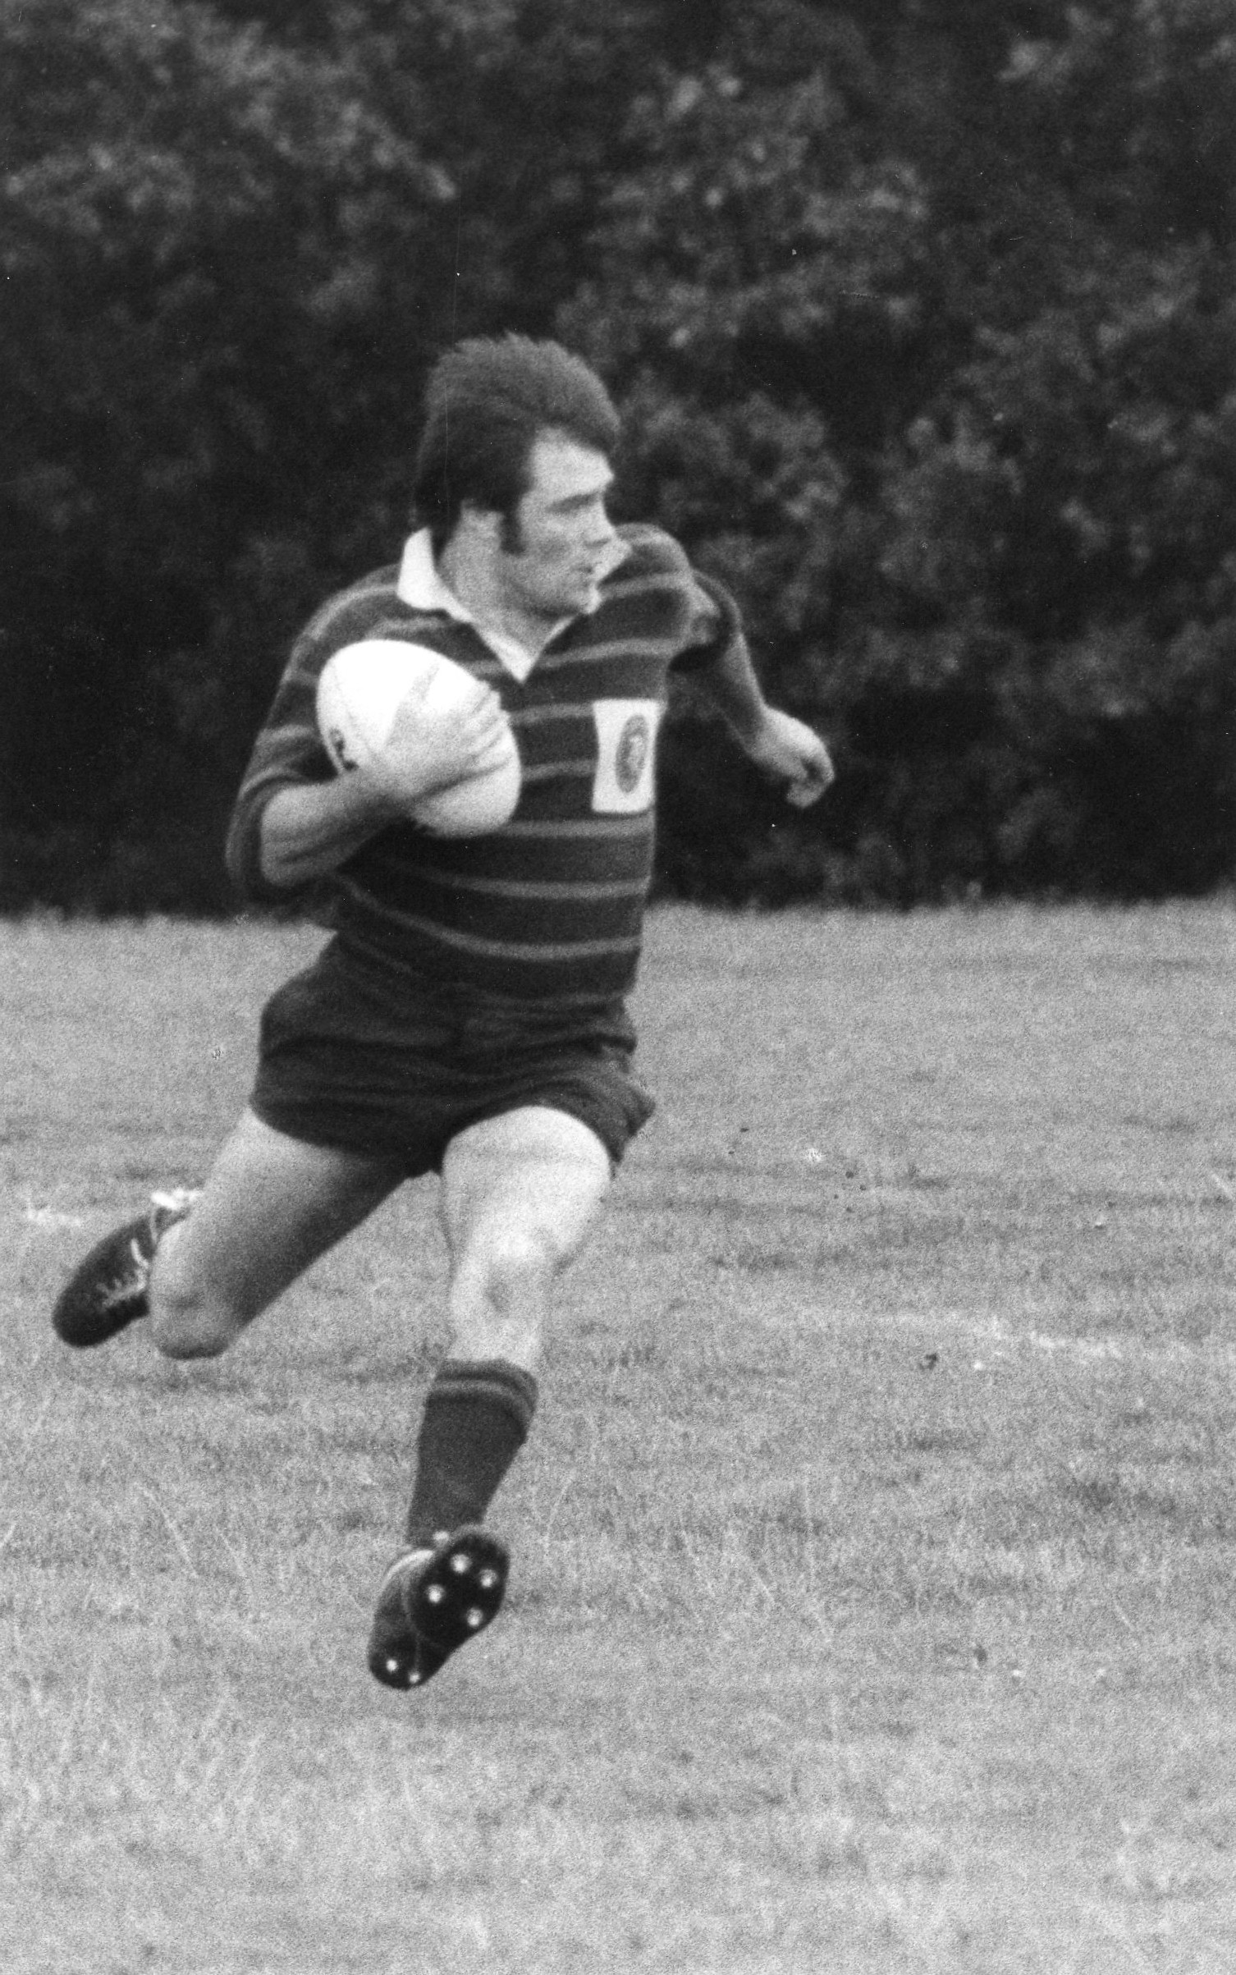Tony had been a member of Trojans RFC and represented Hampshire RFC for many years but was then playing for Ellingham & Ringwood. Through the pub and while playing, they had met many players from the Fordingbridge area and at the time there was only a Sunday club, called Avonvale, that played at ‘the Rec’. There was also a Sunday club at Alderholt for which I played.

Brian and Tony canvassed opinion and inserted an advert in the local press that basically said “if you would like to play Rugby for a Fordingbridge Rugby Club come down to a meeting at the Albany Hotel (opposite the George) at 7.30pm. There was a large response and it was at this meeting that the Fordingbridge Rugby Football Club was launched.

Tony was elected the first club captain. He was very fit and “beasted” the erstwhile attendees at training nights, which went on for about a couple of months before we decided to go for our first fixture in November 1983. This was against “Old Portcastrians” (now East Dorset RFC) at Meyrick Park. We hit the ground running and beat all comers until the end of the season!

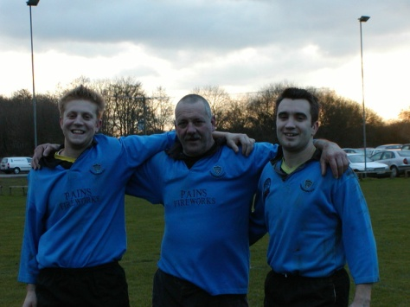

Initially fixtures came from a pool of teams who for various reasons were looking for a game. Steve Godden became our first Chairman and John Trim agreed to take on the job of Fixture Secretary, a role he has carried out ever since. Indeed John did not have a holiday for 26 years!

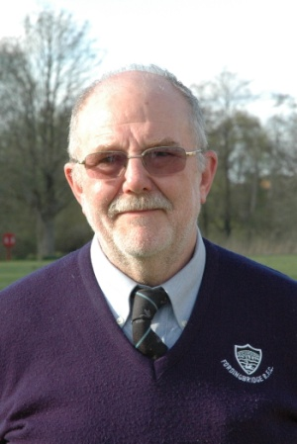 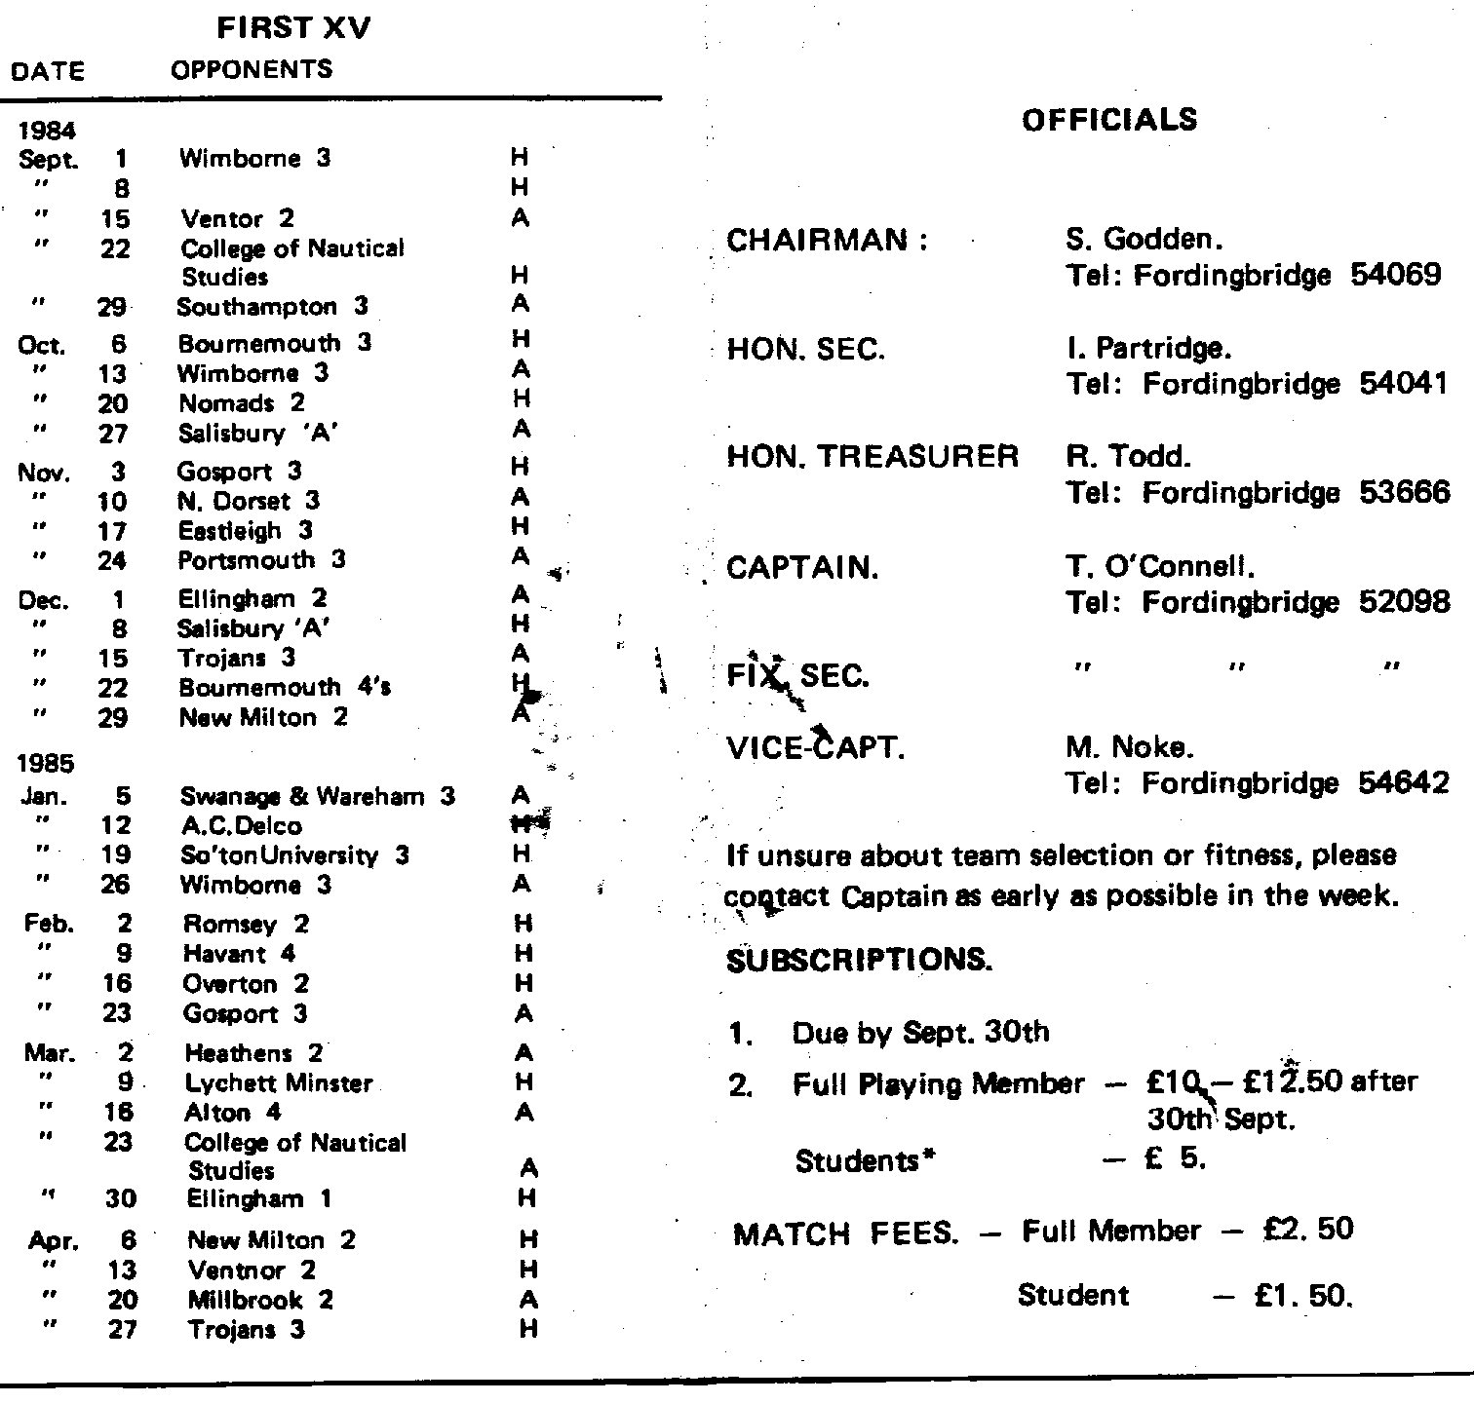

John Trim as he is today ……………..…. and his first ever fixture card

Ian Partridge became the first Hon. Sec. until he left the area. Steve Godden then took on the role with Mike Noke becoming the second Chairman. Tony continued as club captain for a couple of years until Bernie Francis took it on and it was in the same year that Dave Stone skippered our first 2nd XV,

In this period of growth we decided to invite a local rugby aficionado, Mr Stan Howard, to be our first President. Stan had a great love for the sport, particularly rugby and cricket, and had played county level at both. He became a respected referee after his playing days were over and went on to become a national assessor. There was not much that Stan did not know about rugby and, in fact, it was a remarkable coincidence that he had played for Moseley as had Tony early in his career!

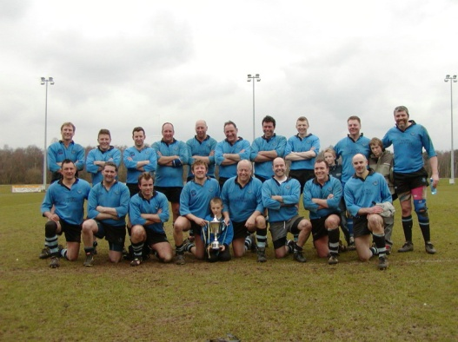All this period was played in the days before leagues, with just friendlies and cup matches, and may I be permitted to reminisce about a couple of memories that have made this Club the all inclusive, family orientated organisation it is today. For instance when visiting the Isle of Wight the host club would provide cars to pick us up from the Ferry Terminal. I can always remember a trip back in a Triumph Herald from Ventnor RFC, after a few beers, when our host driver was very careful not to spill his pint as we careered around the many corners between Ventnor and Ryde!

Then on the first occasion we ever hired Herringtons Coaches from Alderholt for an away match our 2nd XV travelled to Sandown & Shanklin with only nine players, and we were lent three players who scored all the points!! We came home the victors, singing all the way, and as I had known Alan Herrington for most of my life I knew he was staunch Chapel. I therefore apologised every time an ever more, graphic song ensued!

Our first junior section was started by Mike Noke, Brian Fuller and Bernie Francis and, as you will read elsewhere in this booklet, Mike kept it going until John Fisher, Ian Brown, Tony Stone and Martin Norton came along. They all played a significant role in the development of the club, many of their boys now being in the senior squad.

Then there were husband and wife teams, whose input has also been invaluable. John Stockley came to us from Salisbury, and not only was he a great Captain but his prowess as a coach played a major part in helping towards our present success. John’s wife, Nikki, was Hon. Sec. and also an admirable photographer who has contributed greatly to the library of players’ photographs over the years. Now that mantle has been assumed by the seemingly indefatigable Clare Bell and many of her photographs adorn this booklet.

Other husband and wife teams include Phil & Alex Collier, who at one time were Captain and Hon.Sec. respectively, Ian and Sue Brown, and Chas and Teresa Kimber. I could go on but space does not allow.

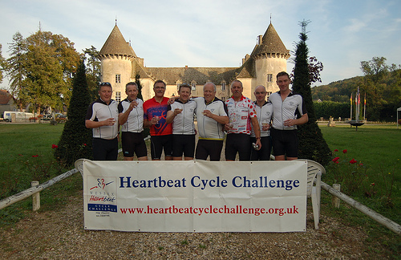Dave Gogin, as most will be aware hails from Mallardville, an area renowned for producing very fertile males! His twin boys are showing signs of real rugby talent and we look forward to seeing them playing in the senior teams. Chris Langford arrived some 10 years ago and was captain within minutes and, along with Adam Dennett, brought a much- needed dynamism to the club. Both Chris and Adam also have talented juniors.

The club has taken part in many fund-raising activities over the years, and I am proud to say that this continues to be the case. Brian Fuller convinced us that cycling was a great sport, and over the last 15 years various teams from the Rugby Club have raised thousands of pounds for national and local charities cycling through France, Spain, Ireland, the New Forest and the Isle of Wight.

One of the club’s key charities, the Hampshire and Isle of Wight Air Ambulance, was brought to our attention by a former Hon/ Sec. Ken Young, and we pay tribute elsewhere in this booklet to the work and enthusiasm Ken instilled in all the members of Fordingbridge RFC for the Hants Air Ambulance.

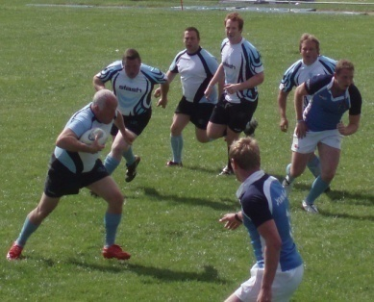A Rugby Club would not be the same without the tours and memories of these abound. For instance there was Alan “Sumo” Coatsworth, on our tour of Torquay, stripping to his boxers, jumping on a pool table and giving a fine impression of a sumo wrestler taking on all comers! Then there was the court case in Bruxelles Bar, Dublin where Alfie Birch made such a good case for his client, our current President, that he was pardoned.

Brian Fuller’s warm-up before the match involved a schooner of sherry. This often involved the car he was in and the other members in the car being late for the match. Once the car was so late that the game began with only 12 players, and when the others eventually turned up Fordingbridge were 12 points up! Then the other three players came on the field and we lost 15-12!

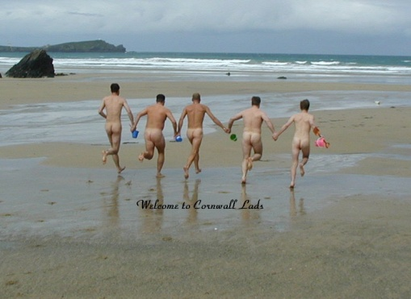On the first tour to Newquay a Court case was held on the beach and all the defendants were found guilty. The sentence was for all of them to run down the beach, hand in hand, wearing only gloves and carrying buckets and spades. The ensuing photo has gone into Rugby folklore! The second tour to Newquay last year was organised by our club captain, Tim Donell, but Tim forgot to mention that the Sevens tournament he had entered us into involved various teams made up of Premiership and International players. However a great weekend was enjoyed by all, although I am not sure about the several hundreds of pounds worth of Pimms consumed though?

Finally four distinguished members of our club are no longer with us but I have no doubt that Brian Fuller, Nick Curtin, Stan Howard and Steve Douglas are organising teams, games, tours and singing their way through the afterlife!

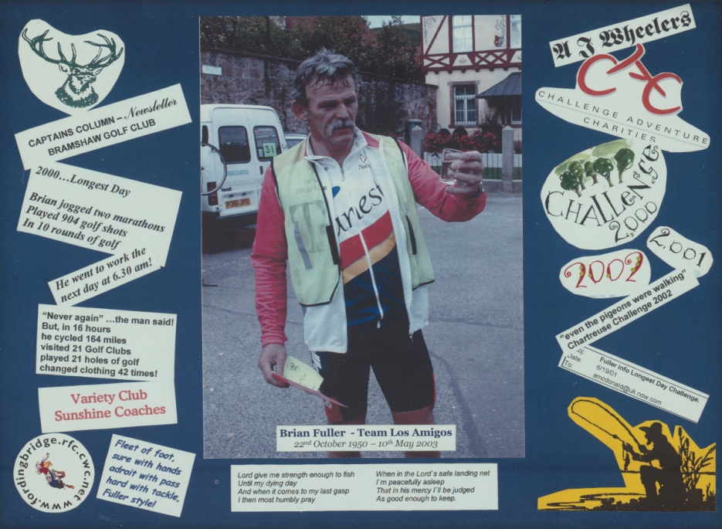

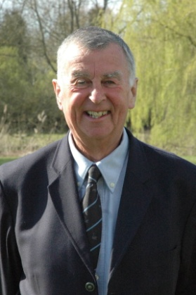**THE ANNIVERSARY SEASON**

**by Rob Burrows**

**Rob, a Fordingbridge Vice-President, handled the media the 1997 British Lions in South Africa and formerly was Head of BBC Radio Sport and Head of ITV Sport. Here he tells how Fordingbridge dominated Hampshire Division One and won promotion in their anniversary season.**

Fordingbridge launched their campaign in the Hampshire League Division One in style with a convincing 15-6 home win over Eastleigh and never really looked back. They won 19-17 at Alton and by the third game, a 10-0 home win over United Services Portsmouth, they had already moved to the top of the table. However the first of only two defeats all season came next at Farnborough who won 27-13, but Fordingbridge then got back to winning ways by hammering Southampton 32-3.

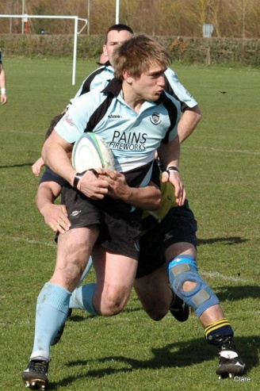By this time James “Badger” Greenwood, who had been marching up and down the touchline in support of Head Coach John Holden, had entered the fray while still on Newbury’s books, and “Badger” was to prove an inspirational hooker for the rest of the season. In the next game, Fordingbridge were all set to secure an important home win over Sandown & Shanklin when a Sandown player was injured and the match had to be abandoned with the Hampshire Air Ambulance in attendance.

The game was replayed the following Saturday but Sandown & Shanklin had strengthened their team and forced a draw at 10-10. In the next round of matches came an astonishing result with the Isle of Wight side beaten 22-14 at home by Alton, while Fordingbridge scored six tries and won 45-37 at New Milton. Then came the club’s sixth win of the season, 16-0 at home to East Dorset, while their two closest rivals, Sandown & Shanklin and U. S .Portsmouth, drew 8-8.

Just before Christmas the scheduled match at Romsey had to be postponed because the referee failed to turn up and, with the first weekend of the New Year wiped out because of snow and frost, the team went back to Romsey and romped to a 41-0 win, again scoring six tries and notching their third clean-sheet of the season.

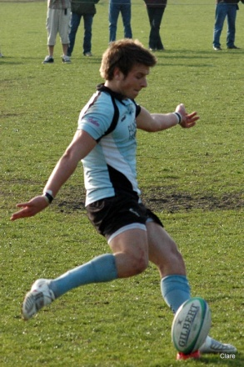On January 24th 2009 came perhaps the defining moment of the season. Nobody can remember Fordingbridge ever winning at Sandown & Shanklin but this time they did, hitting back after conceding an early try to score an historic victory 24-10. Mat Norton, who throughout the season proved himself a prolific place-kicker, scored 19 of the points with two tries, three conversions and a penalty. Meanwhile U.S. Portsmouth were surprisingly beaten 10-6 at Romsey and Fordingbridge were now top of the League with a game in hand, a lead they were never to lose.

Southampton, on their own ground, were the next victims though the match was far closer than final result of 18-9 suggests. Then came revenge against Farnborough, with Fordingbridge running out winners 27-10 and showing a very satisfying strength in depth. For example, Mat Norton was away and with his replacement, Steve Brown, injured early on Dee Stone stepped up to control the game.

However, in the next game, Fordingbridge suffered their second and only other loss of the season, going down 24-15 at U.S.Portsmouth amid some bizarre refereeing decisions. It was a match that they could, and should, have won.

March started with seven tries, including a hat-trick from Mat Norton, in a 43-6 win over Alton. There followed a crucial weekend when Fordingbridge won 25-19 at Eastleigh but U.S. Portsmouth were beaten at home 20-12 by Farnborough and Sandown & Shanklin lost 14-7 at East Dorset.

At that point the League was as good as over although there was one more fright to come when New Milton stormed into a 19-0 lead in their rearranged game at the Rec. However Fordingbridge rallied like the champions they were to become and eventually won 33-19, a fitting result for the captain, Tim Donell, who was playing his 100th 1st XV game for the club.

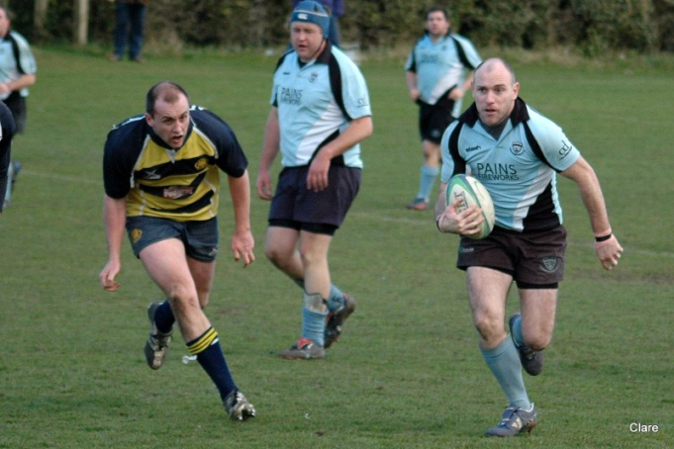The title was finally decided in the penultimate match when, with vociferous touchline support after a boisterous Vice-Presidents’ lunch, Fordingbridge overcame Romsey 34-12. Dean Lewis, who with James Greenwood had so often been in the forefront of the forwards attack all season, scored two of the five tries and the match was also notable for an amazing 80 metre run from full-back Tim Brittan. It was positive, attacking rugby and the large crowd were thrilled to see the club go five points clear and win the Hampshire League.

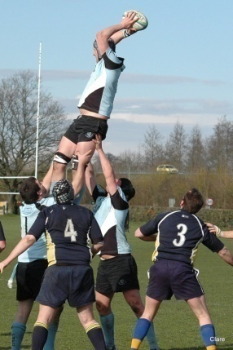The celebrations continued in the town well into the night, and the season ended as it had begun 25 years ago. In November 1983 East Dorset were known as Old Portcastrians and Fordingbridge came out on top - as they did in April 2009 when they beat East Dorset 26-3 and so won their final match in the 25th Anniversary season. Meanwhile Sandown & Shanklin won 11-8 at U.S.Portsmouth and so qualified for the play-off in which they beat Old Whitgiftians 17-10 to join Fordingbridge in the London South West Leagues. The Isle of Wight beckons again!!

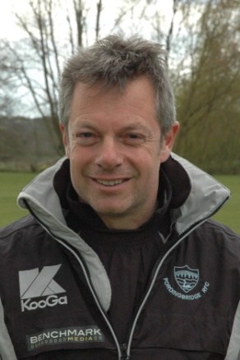**FROM THE COACH** by John Holden

**Since coming to Fordingbridge some 12 years ago John has become a passionate member of the club, playing regularly for both senior teams. However it was only two seasons ago that he assumed the responsibilities of Head Coach and here he looks back on the last two years in a very personal way.**

Exceptional groups of people don’t come around often, when they do they must be treasured and nurtured. For the two years I have had the privilege to be involved in coaching the senior squad at Fordingbridge I have watched them grow and evolve into what is, without doubt, an exceptional group.

The opportunity to coach these players, in such an inclusive family club environment, is equally an honour and a pleasure, but first, and foremost, it is a huge responsibility.

Get it right….and the players will improve individually, able to perform over and above their level, making the team output ‘greater than the sum of the parts’!

Get it wrong….and poor performances will spoil the fun. We don’t play to lose!

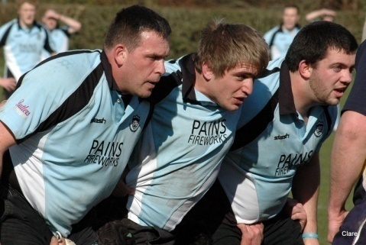The keys to ‘getting it right’ this season were cut at the beginning of the 2007-08 season. We blitzed our core skills and intensified out whole approach to training with positivity, focus, fitness and discipline becoming the core elements.

With our ‘training culture’ established we began, with quiet confidence, to develop and enjoy our ‘way of playing’. Keeping it simple, playing to our strengths and working on our weaknesses. We have learned a lot about ourselves in the process and it has been fun. At the beginning of the season we would have been OK with a mid-table finish but by the end we were disappointed to finish fourth.

Backed by the committee’s enthusiastic support, encouragement and investment at the AGM we set ourselves a clear and challenging target for the 2008-09 season, the Club’s 25th: To win both Hampshire Division 1 and Dorset & Wilts Division 3 South.

Looking back at the season now, after 74 training sessions and 18 Hampshire league games, it seems to have flashed before our eyes, but what we have seen is extremely gratifying and can be simply summed up by our league statistics:

The 1’s: league champions, a +231 points difference, 59 tries, 37 players involved and unbeaten at home.

The 2’s: league champions, a +523 points difference, 96 tries, 57 players involved and also unbeaten at home.

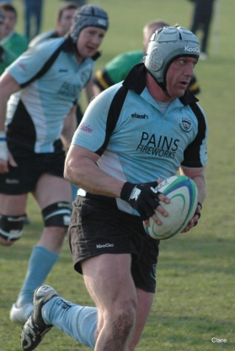Our 1st XV performances have been built on leadership, not only from Tim Donnell – an outstanding captain – and positionally by those playing in the ‘spine’ of the team: Badger (James Greenwood), Deano (Dean Lewis), Jim (Newton), Norts (Mat Norton) and Tim Brittan. Badger’s arrival from Newbury has lifted the whole team, Deano continues to slice through defences from No. 8, Jim and Norts have linked well and got the back line going and Tim has run some great lines from 15 – his best position.

To name only a few players is not to understate the parts played by those not named. We all know what you all did, and a key aspect of our success is our aggressive defence which involves everyone. All 37 who played should be proud.

At the end of a successful season it is difficult to say anything about ourselves without the risk of sounding satisfied which would be misleading because we have a huge appetite for hard work and improvement. A simple solution is to borrow some words from an opponents’ match report:

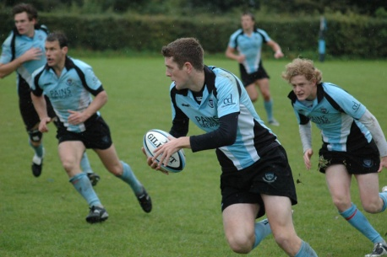“**On the evidence of this seven-try blitz against Alton, Fordingbridge fully deserve to take their place in the London leagues next year. They were terrific and the scoreline did not flatter them one bit. Their brand of rugby is too good for Hampshire One. The backs play with flair and inventiveness, with power and pace in spades, excellent lines of running, and above all an intuitive awareness of who and what is around them. In fact, all 18 players, who wore sky-blue shirts looked comfortable with the ball in hand; they regularly had an extra man in attack and they always sought to use him, regardless of the number on his back.”**

Someone once said “flattery is fine as long as you don’t inhale” and we will not!

Hitting our ‘**win both leagues’** target is something the whole squad is proud of and along the way we have learned a lot about ourselves, particularly the importance of both communication and discipline but, most of all, that the real work is just about to begin. For me a real challenge is that, as yet, we have neither played to our full potential nor produced an 80 minute performance.

To succeed at a higher level we must now raise the bar in all areas, particularly our fitness levels, physical intensity at the breakdown and defensive organisation, all of which will be core to our preparation for the 2009-10 season. Recruitment will also be necessary.

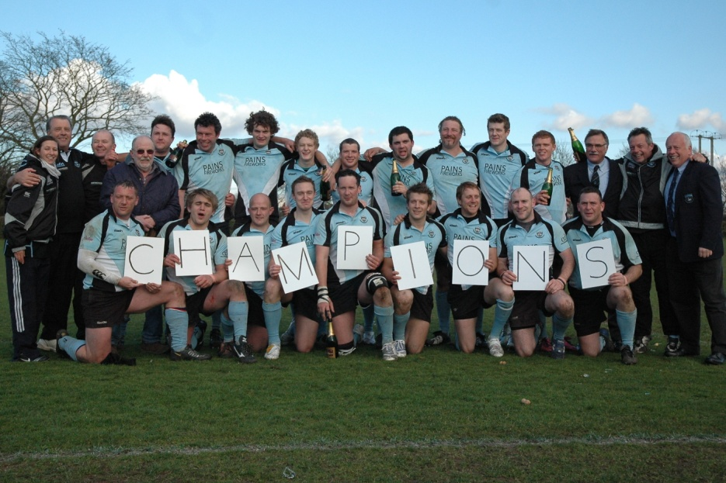There is a great deal still to come from this exceptional group, many more great games to be played, enjoyed and won and no doubt, some painful defeats to endure, learn from and to bounce back from. As a Club….we cannot wait!

Bring it on!

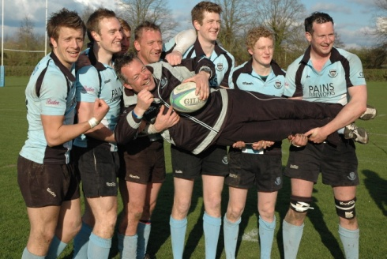

**CLUB WIN DORSET & WILTS LEAGUE AND NEW FORSET COUNCIL SPORTS COUNCIL AWARD**

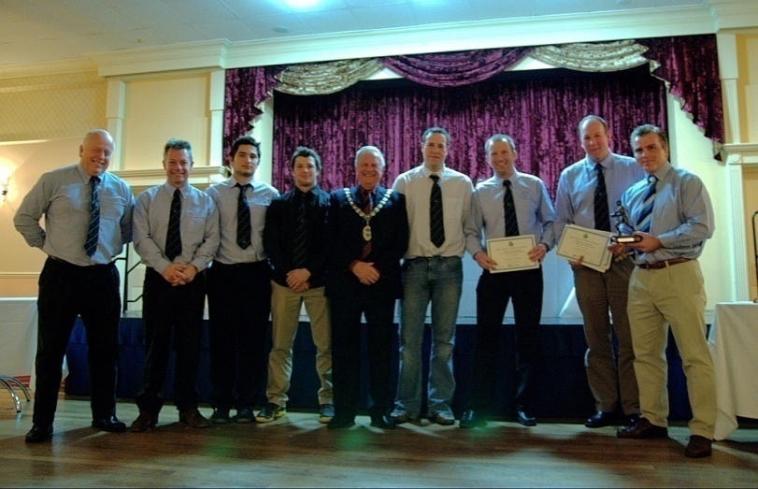

**James Potter (second from right) has been in charge of the Fordingbridge 2nd XV, as manager and one of the coaches, for only a season and here he recounts what a memorable anniversary season it has been.**

Having won the Hampshire Merit 2 Table at the end of the previous season, the club sought new challenges over the border in Dorset & Wilts Division Three South and, and in a close-run encounter with Ellingham & Ringwood, we won that League too to make it an anniversary season to remember.

We had topped the Hampshire Merit Division Two table for the second time in four years and, with 10 wins in 11 matches and a 95% results tally, we were awarded the New Forest Sports Council’s Sports award in the senior team category for 2008.

This was due reward for a team that is a blend of enthusiastic youth and gnarled experience with an age range dropping from somewhere in the mid forties down to seventeen. It is proving a useful development stage for a number of the local youngsters, learning from more seasoned players, while cutting their teeth on senior rugby and staking their claims for promotion to the first team.

Furthermore, not content with having played hard on the Saturday afternoon, eight or nine of the regular 2nd XV squad will be found at the Rec on a Sunday morning either coaching, or assisting the minis and juniors.

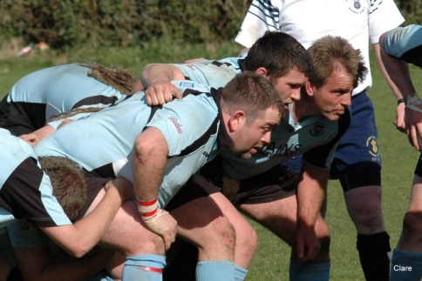Anyway we announced our arrival in the new Dorset & Wilts league with an 80-point thrashing away to Blandford. Maybe the news spread, but Dorchester called off our next league game! Not being one to shy away from a challenge our captain, David Timms, kindly invited a strong Tottonians side over instead and despite some stiff resistance we went down to a heavy defeat.

With the lessons from this quickly absorbed the team began to find their rhythm and we went on an 11 match unbeaten run up to Christmas. So we ended the year top of the league, including a notable double over local and league rivals Ellingham & Ringwood.

After the Christmas break, which was extended by the snowy weather, we travelled to Oakmedians, and our confidence turned to bemusement as we saw the equivalent of two teams warming up at the other end. A league rule allows unlimited substitutions, enabling Oakmedians to give game time to 31 players, but we were actually undone by our own errors and lost. Our first league defeat was a bitter, but galvanising, pill!

The loss meant that we slipped to second in the league behind E’s, but with games in hand. Meanwhile East Dorset, and latterly Dorchester, were bumped from the league for not fulfilling enough games, so we lost our points difference cushion too!

After the Oakmedians’ reverse, the team embarked on another unbeaten run but, with two games to go, Ellingham & Ringwood still headed the league. However they had completed their programme and a well earned 60 -10 victory against Poole took us back to the top of the league on points difference.

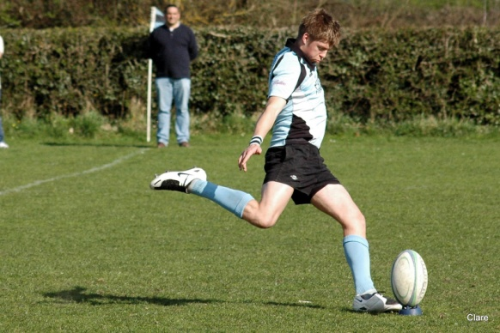

The final game was away to Puddletown where, with a strong team and a coach load of support, we ran out 57-0 winners to clinch the league title. The celebrations started at the BBQ, generously hosted by our opponents, continued all the way home and long into the night.

The foundation for this success came from the combined squad training that allowed new combinations to blend easily into the game plan. This majored on a solid defence and was helped by a group of fast young backs, who could strike from anywhere on the pitch. With 62 players representing the side throughout the season, there are too many stars to mention them all.

The pack, lead by skipper Dave Timms were solid in the set and a well drilled lineout. Notable contributions came from Rob Sallows, Chris Leaton, Dave Gogin, Mike Parry and Jon Vass. Throughout the pack secured plenty of ball for the backs to score from.

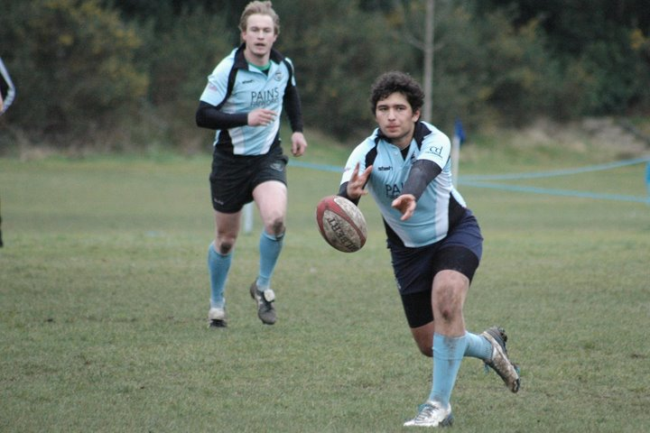The backs were orchestrated by Mike Parke at fly-half, who released the potential of inside centre Mark Hammond, who scored 11 tries, full-back Sam Hawker, with nine the same as winger Liam Raymond. Liam was also top points scorer with 60 conversions and 8 penalties, and a total of 171. Special mention should also go to the vice-captian, Mark ‘Kiwi’ Newton, who really needs to work out his best position having made 13 appearances at 6, 7, 8, 9, 10, 12, 13 &15!

It’s been a fantastic season of running rugby, dogged defence and many a laugh, so many thanks to everyone who played their parts, great and small, during the course of the season.

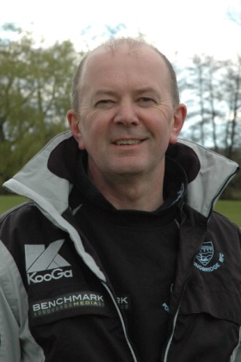**JUNIORS AND MINIS**

***The early years*** **with Ian Brown**

**Ian is Chairman of the Fordingbridge Sports Club, and for the last four years has been the 1st team manager. Throughout the 1990s he played an influential part in the development of the mini and junior section which had been started by Mike Noke. Ian takes up the story.**

The thriving mini and junior section that Fordingbridge now has is due in no small way to the inspiration of Mike Noke, who towards the end of the 1980s had become Chairman of the club. In Mike’s own words this was his vision statement:

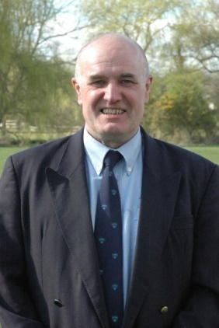“***I always felt that for the club to survive we would need to ‘breed’ our own players for the future and the best way to do that was to start mini-rugby. The vision was that in eight to 10 years we would have players coming through to the senior sides. So, Brian Fuller, Bernie Francis and myself started it off one Sunday morning in the late 80’s with about 20 boys turning up. The vision has come to fruition and it is something of which I am very proud because the mini-junior section has grown to what it is today with over 200 boys and girls attending every Sunday morning with players regularly coming through to the senior teams, including our present club captain.”***

I got involved in 1991 when Tony Stone and I took our young boys along one Sunday morning. Dan and Dee were then seven and Steve only five. We found an enthusiastic and committed band of youngsters and Mike suggested that Tony and I become involved in the coaching side of the game rather than just standing on the sidelines. Here I am 18 years later still heavily involved in Fordingbridge RFC as is Tony!

One of our first games was at New Milton where we played in a variety of shirts! We had to put that right and so, with the generous sponsorship from Pains Fireworks we were able to buy further stocks of the famous sky blue shirts.

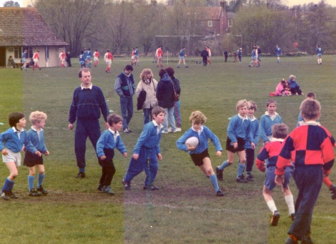In that first season we also went to the county tournament at Petersfield for all Minis from 7’s through to 12’s. We were able to field full sides at a couple of age groups with the older boys going along under Mike’s guiding hand and teaming up with other clubs to form a Barbarians-type side. However it rained all day and we could not take part in our semi-final as everyone – players and adults – were wet through and freezing cold and, having been there from 9am to 3pm, many teams had had enough and gone home, leaving us without any opponents!

This was also the year England reached the World Cup final at Twickenham only to lose to Australia. It prompted a massive upsurge in interest and was the springboard to a whole raft of new helpers who became coaches and an influx of players both boys and girls at Fordingbridge.

A number of us took our RFU preliminary coaching qualifications and this was when I first met the inspirational Will Feebery, then Hampshire RFU Youth Development Officer and now an RFU National Coaching Development Manager. Will was a major influence on my Rugby life.

Our first major competitive success came in becoming Hampshire U11 Plate Champions 1996/1997 at Alton captained by Alastair Mullens, with Steve “Sauce” Brown in the team. We also entered the annual London Irish Mini event where we had the chance to pit our skills against teams from across the country. It was a great experience and a chance to meet the stars such as Dean Richards, Ben Clarke and Kyran Bracken.

In the 1998/1999 season we realised we were unable to sustain both the minis and the juniors so we came to a sharing arrangement with Ellingham & Ringwood with our minis joining them and their juniors coming to us. We then had two junior sides which we sustained through to U17/18, and at this time Martin Norton and Paul Mooney lent fantastic coaching support.

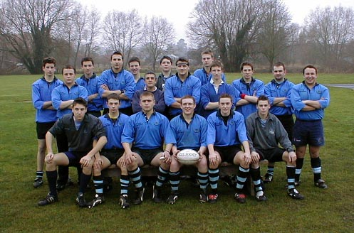Both age groups produced Hampshire county players, with James “Badger” Greenwood going on to represent England Under-18s. Before that, in 1998, Greenwood had been in the Under-14’s, coached by John Fisher, who became Hampshire county champions with Keith “Beefy” Walsh, Stuart “Fish” Fisher and Dee Stone in the team, while in 2002 the Under-16s won the New Milton Sevens with current players Mat Norton, Steve Brown, Rory Williams and Sean Gorman all in the side.

During this period Colin Watson-Newman had become the driving force behind the Fordingbridge Junior Sevens tournaments at The Rec, there was an “infamous” tour with the youngsters to Ireland and there are so many who will have fond memories of their time at Fordingbridge.

Those who now regularly play senior rugby for the club include Tim Donell, Nick Dymott, Mark “Kiwi” Newton, Tim Godden, Dee Stone, James Greenwood, Mat Norton, Keith Walsh, Nick Mowbray, Sean Gorman, Matt Vass, Rory Williams and Stuart Fisher as well as my two sons, Dan and Steve.

It is impossible to mention all those willing souls who have coached, helped and organised over the years, indeed it would be invidious to do so, but it is a testimony to Mike Noke’s vision that in this our 25th Anniversary season we have so many former minis and juniors in our squad of senior players good enough to win two county Leagues.

***The modern era*** with Sarah Bealey

**Sarah handles the PR and co-ordinates the website for the mini and junior section, ensuring that the youngsters get plenty of publicity in the local press. In this article she tells the story.**

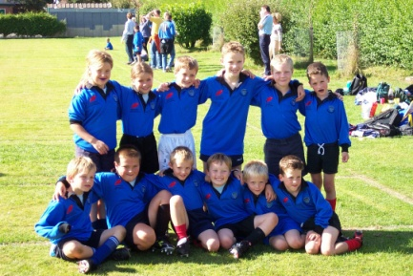The re-formed mini section was launched in September 2002, with teams at under 7 & under 8, a few of whom had successfully started their rugby careers at other local clubs, and those who came because they or their friends had Dads playing for Fordingbridge. The most important message about those days is that we wanted it to be FUN and this is still our most dearly held value today.

On the first Sunday 22 children appeared, and numbers have steadily grown as the age groups have moved up each year. This season nine of the original group are still playing and, in all, 214 children have registered for the club in this anniversary season, with an average attendance of 140 children spread over 10 age groups from under 5 to under 14.

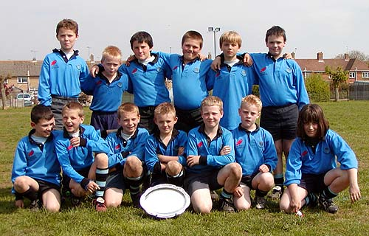From the re-launch there are pictures of the under 7s and coaches who won the Wimborne Tournament Plate in 2003 and under 9s who won their Wimborne Tournament Plate in 2004. Over the seven years these squads have steadily progressed to the under 13s and under 14s and last year we entered the Hampshire League.

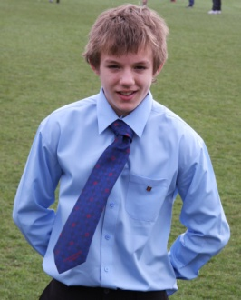At the end of this season, where some clubs withdrew from the league due to lack of player support, our Under 14s finished fourth in Hampshire League Division Two above much larger clubs such as Romsey and Gosport & Fareham. The Under 13s reached the quarter finals of the Plate in their Hampshire Cup competition – knocked out by Havant.

Individual success has been remarkable in such a short time with Chris Marshall selected for the Hampshire under 14 county squad this season. Paddy Marshall, also from the U14s, Lewis Dennett and Will Timms from the Under 13 squad also made it into the Elite Player Development Group at Bronze Level. Fordingbridge players selected for County or Academy trials included James Vincent, Ross Bealey, Jed Barnes, Sam Joy, Ollie Fower and Ben Kirby.

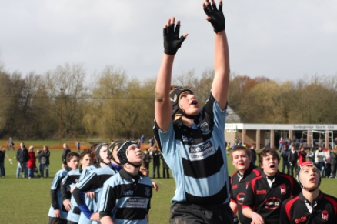We also participated in other Hampshire Rugby development events such as Prop Idol, and had a fabulous success in February 2008 when James Vincent went to Tottonians for the first roadshow and won.

As the club has grown, the original small group of helpers, led with unbelievable dedication & commitment by the Chairman of the Junior section, Chas Kimber and his wife. Teresa,, has expanded considerably. We have recruited coaches from a mixture of current players, parents and friends. Team coordinators liaise between parents, players and club officials to organise PR & Website, fixtures, schools liaison, the kit shop, child welfare, first aid and Catering support.

All helpers are offered training and development to keep skills up to date and the club liaises with the Hampshire Community Rugby team in Winchester. A committee now manages operations and decision making alongside Chas & Teresa, with volunteer representatives from all sections of the club. A real milestone was reached last year when Nick Dymott, who started playing for Fordingbridge at 16, joined the coaching team – an experience he announced as ‘really rather weird’.

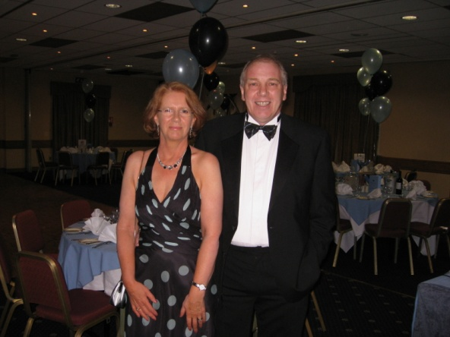

The section has been very fortunate in attracting good levels of sponsorship and all involved are grateful for the continued support from the companies and individuals concerned. In our first season Pains Fireworks gave permission for their sponsorship to be allocated in total to the mini section, which allowed us to start off with a full set of kit. In recognition of this the mini section, under 7 – under 12, is proudly known as “The Rockets”. Other sponsors over the years include South Coast Construction, Vincent’s Wholesale Underwear, New Dimension Builders and Collier & Dobson Ltd.

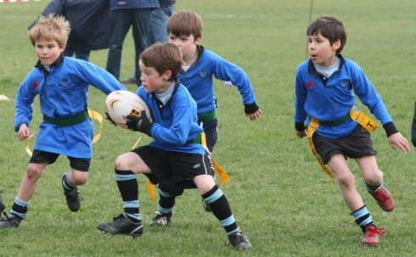For a small club we have had some notable successes at various tournaments as the silver in the club’s display cabinet will attest. We had a particularly good run in September 2007 when we were either winners or runners up in five out of six age groups at the New Milton Tournament, while in the previous season our under 7 team won every tournament they entered, including the county tournament, a great achievement.

We have always looked beyond winning matches, placing great emphasis on coaching the skills that will lay the foundation of many years of enjoyable, safe and successful rugby. We also encourage the children to enjoy the social aspect of the game. From a glass of juice and a biscuit after every session to “sit-down” lunches after games once the players reach the under 13 stage. There is great satisfaction in seeing young people from such a wide variety of backgrounds develop their social

It’s also great to see the whole community coming together on a Sunday morning and we have tried hard to make the experience a good one for parents too – hot bacon sandwiches from the barbeque and a mug of coffee helping to ease the pain of a foregone lie-in, sore throat from yelling encouragement and frozen, touchline toes! If that doesn’t do the trick, the bar is usually opened for a sociable, lunchtime drink while the children continue to have fun on the pitches outside.

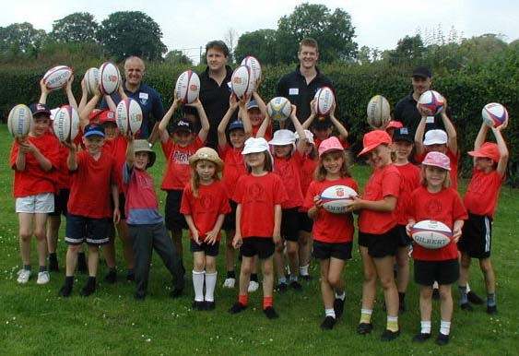From the first, recruitment has always been a priority. We have developed links with the local schools where we run recruitment days and help them with after school clubs and with preparation for tournaments. This year sessions were run in most of the area primary schools and contacts made with local comprehensives and Forres Sandle Manor. Posters advertising the club are placed each year in pubs and on notice boards to ensure that the recruitment effort is maintained.

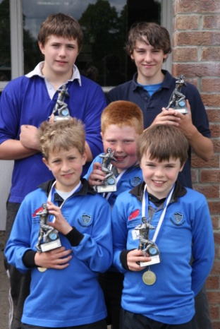We have a dedicated section on the Club website where we are able to place general information for parents, fixtures lists, application forms and most importantly, news and photos for each age group. From the very first day we have enjoyed the support of the Seniors and consider ourselves to be one part of a great club, and we look forward to welcoming the next generation to the 50th Anniversary.

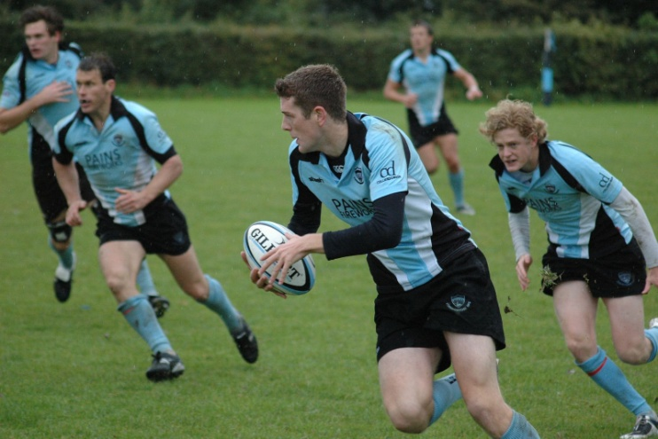**THROUGH THE RANKS**

**with Dan Brown**

**Dan is now firmly established in the 1st XV at Fordingbridge. A schoolmaster at Burgate, he has been – or shared – the accolade of the team’s top try-scorer. In this article Dan tells how he joined Fordingbridge as a seven-year-old and came through the ranks.**

In 1991 I persuaded my Dad, who is now the first team manager and who has always been a major influence on all my sporting life, to take me, my brother Steve and best mate Dee Stone down to the Rec to have a run around on a Sunday morning. We immediately fell in love with a game, where no matter what size or shape, or how fit or fast you were, you would always have a role to play.

I had become highly motivated while watching the 1991 Rugby World Cup in which England had reached the final. This was a feat that subsequently has only been equalled by the cricket team who finished runners-up in the 1992 Cricket World Cup and the Rugby teams of 2003 and 2007.

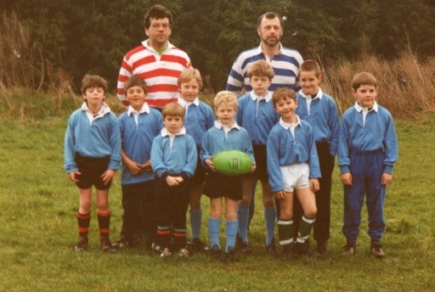In those early days things were very different from now, Steve as a five-year-old was in the same team as Dee and myself at seven and eight respectively and everyone played touch Rugby together. The likes of Steve Douglas and Mike Noke motivated and encouraged everyone on those cold Sunday Mornings.

My everlasting memory will be of a cold, wet and windy day on the Isle of Wight (as every trip to the Isle of Wight seemed to be!) yet still thoroughly enjoying myself.

As I have said, my Dad has been a huge influence on my sporting life and, as I grew up in the minis, he became a prominent coach and eventually took over the organisation and running of the mini section. As everyone knows behind every good man there is a woman, and behind the scenes at Fordingbridge there have always been a fantastic team of motherly/sisterly supporters.

Every Sunday food was, and of course still is, provided by the club for players, coaches and supporters to keep them warm on those cold mor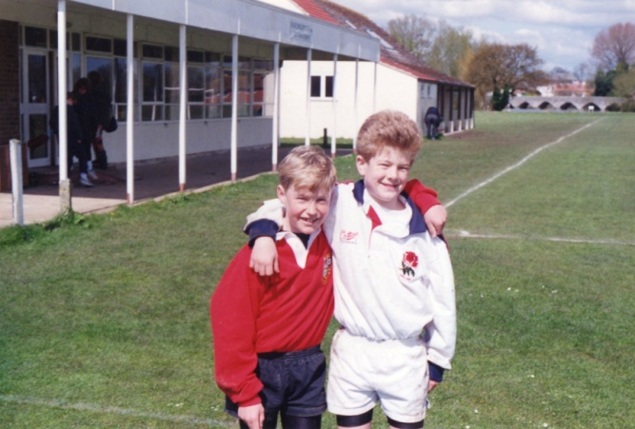nings and to make sure that as always Fordingbridge is a friendly and welcoming club.

Over the past 18 years I have seen the club grow and develop, at one stage there were only two junior teams running and as one progressed into colt’s rugby and then onto men’s it meant that everything was changing but the development did not stop there.

There was always a fresh batch of youthful, exuberant minis waiting to play again - the sons, daughters and nephews of 1st and 2nd XV captains and players. At this point early in the 2000’s Chas and Teresa Kimber took over the running of the junior section, and they have truly done a magnificent job with an average attendance on a Sunday morning near 150. .

Having progressed from mini to junior and now to senior, it is great to see the talent coming through whether they be the next batch of county or academy players, or those just turning up to have a run around with their mates. It will be another four years before they can play senior rugby but I can’t wait!

As a teacher at Burgate School I am now nurturing that talent and can already see those who will make outstanding rugby players. As a local PE teacher it is fantastic to have such a great club on your door step, who do so much to promote the great game and develop those youngsters who want to play.

You can now go down to the Rec on a Sunday morning and see just how many people in the local community Fordingbridge RFC effects No matter what the weather you still have the diehard coaches and players, parents and siblings. Fordingbridge really is a family club.

In addition to my Dad, so many people have influenced my playing career from mini to senior. It is a testament to the coaches and committee of the club that we currently have over 10 players playing senior rugby that at some point have also played as juniors and minis in the blue of Fordingbridge.

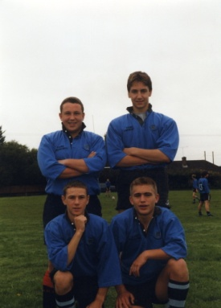Two former London Irish academy players came from our junior ranks, James Greenwood and Dee Stone James went on to represent England U19s, and we currently have two U14 players training at Sunbury (with London Irish )month. It is definitely a good time to play or support Fordingbridge RFC.

I look back on the days of mini/junior rugby with fondness. It is where I first realised I wanted to teach and coach, and where I learnt the true meaning of teamwork and team spirit. I really do love the game and I owe it all to Fordingbridge RFC, without whom I probably would not be playing today.

It must be the friendliest club in the South and if you have not had a chance to savour the exciting rugby currently being played throughout the club, from 1st XV to Under 7s, go and have a look on a Saturday or Sunday to see what it means to play in the blue of Fordingbridge.

The club has been a huge part of so many people’s lives and I look forward to playing my part in the future, whatever role that may be. The Rec is now a fortress for our senior teams and the opposition hate to play there. What with this, and a thriving mini and junior section, I cannot wait for the next 25 years, whatever they may bring.

**THE VICE PRESIDENTS**

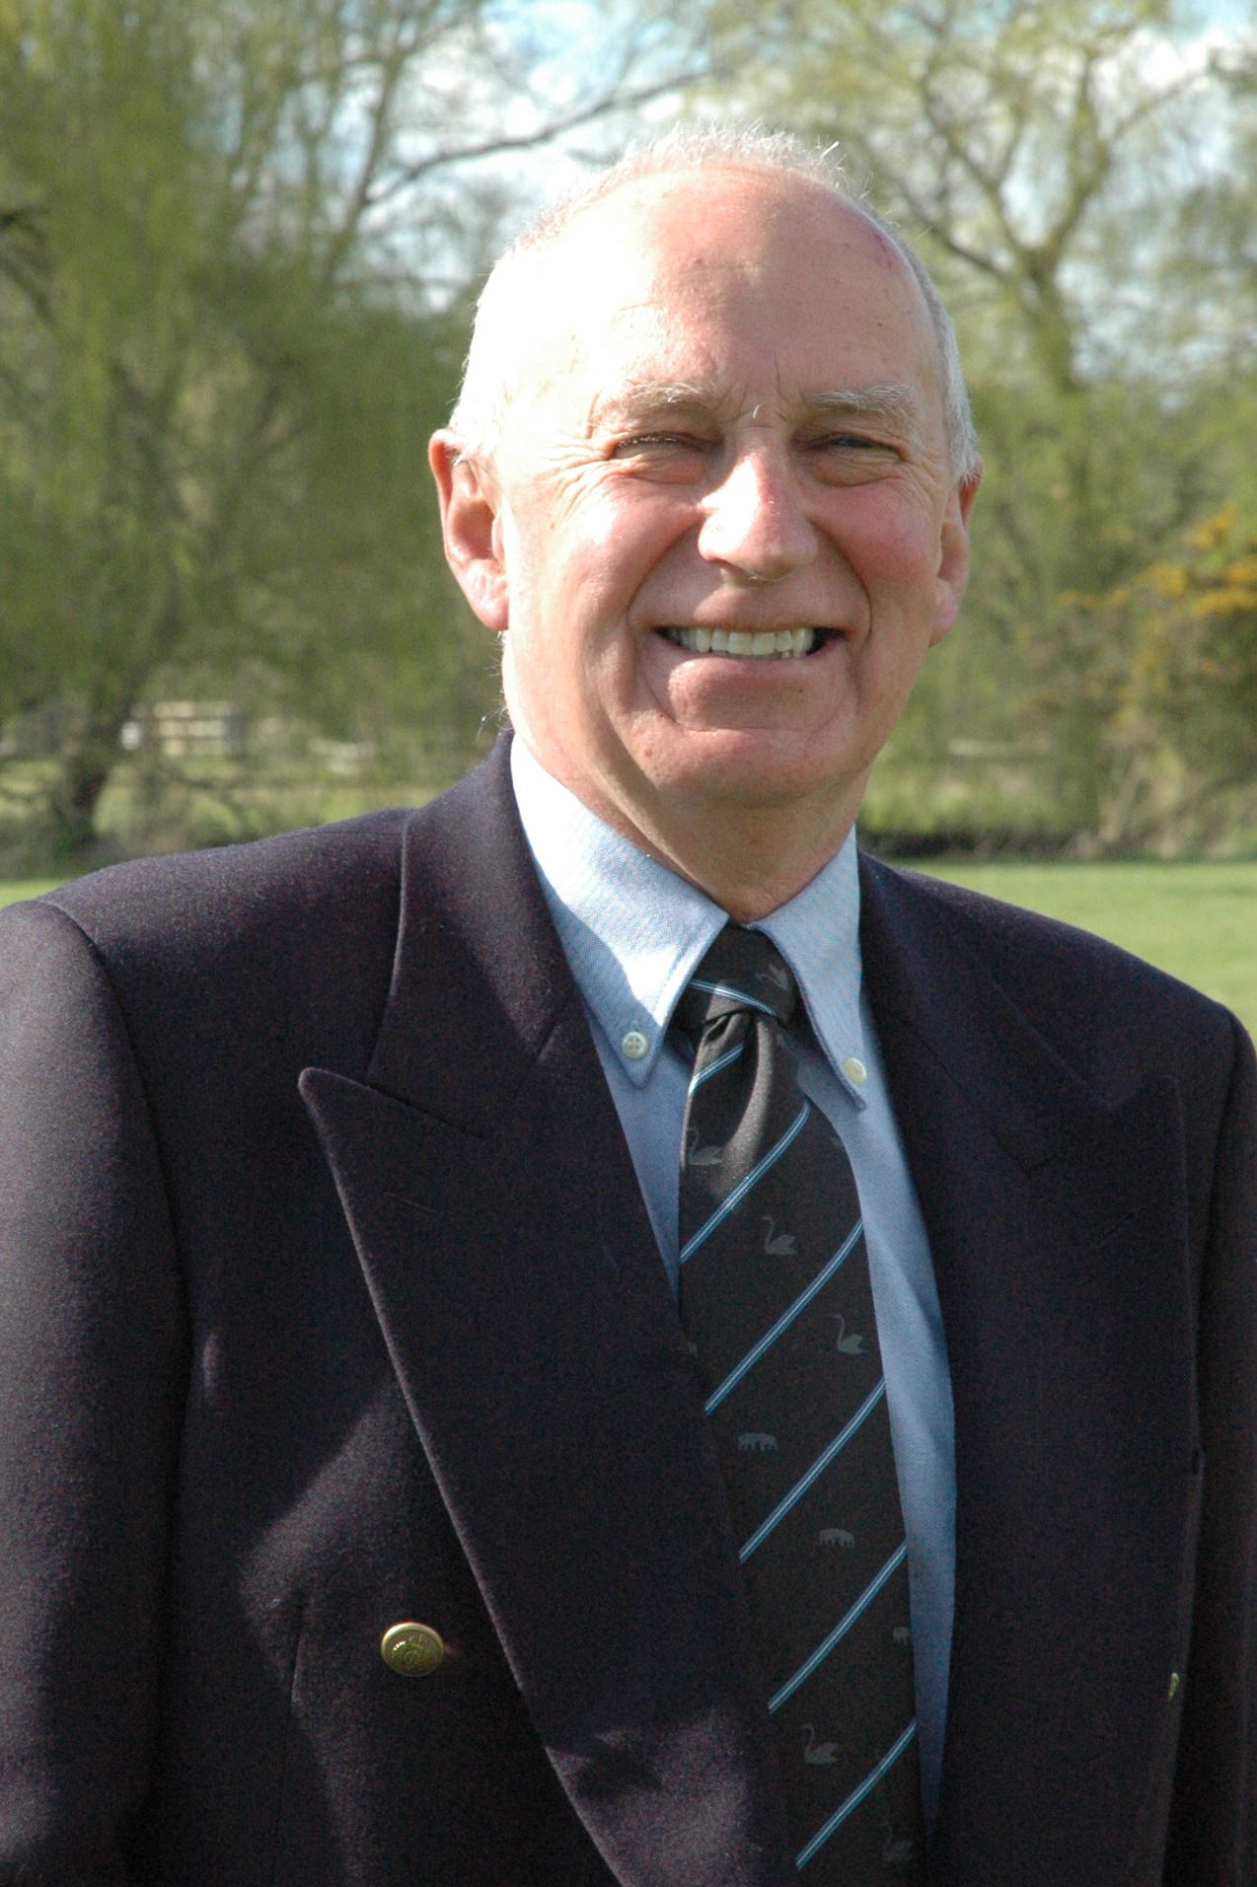

**By John Marsh**

**John is the Secretary of the Fordingbridge Sports Club, and the coordinator of the Vice-Presidents at the Rugby Club ensuring that there is plenty of support for the teams**

The Vice Presidents are from a range of backgrounds with the majority being ex-players and the rest being local residents. But there is one thing that binds them all and that is firstly a love of rugby, and secondly the chance to share a pint or two in the clubhouse after the game.

They play a vital role in touchline support through the season both at home and sometimes away and this support is much appreciated by the players The transition from player to vice president is always interesting as each one faces that agonising decision of when to hang up their boots But of course it is not as clear cut as that as many of the VP’s continue to occasionally appear for the club due to injuries and unavailability in the squads.

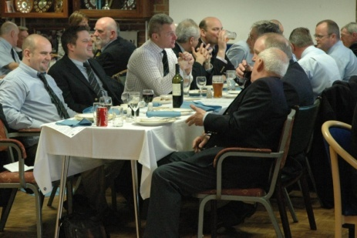One of the highlights of the year are the two or three VP lunches before a home match when we always put the world to right in the clubhouse before making a mass exodus to the touchline for the match. As a player Chris Langford says he was always nervous of the VP lunch matches when the expectations of the VP’s were not always matched by the performance on the field – a situation that has produced many barbed comments from the touchline over the years. Of course now Chris has crossed the line from player to VP status and he feels entitled to offer his words of wisdom if things are not going to plan.

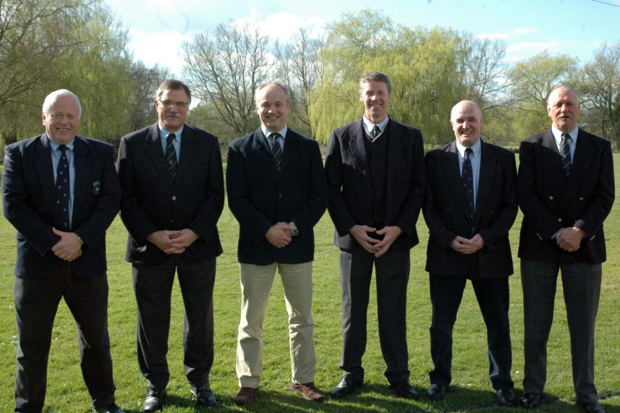The last VP’s lunch on 28th March had a record attendance of 50 VP’s and guests. It included six players – John Mouland, Tony O’Connell, George Pollard, Doug Park, Mike Noke and Steve Godden - from the foundation team back in 1983 and many others who have played and carried on supporting our club as it has progressed to where it is today. As well as being passionate about their rugby the other common factor amongst the VP’s is their appreciation of the “craic” which is very evident once Messrs. Birch, Timmins, Deeker etc. get onto the touchline.

One of the referees this year likened the touchline VP’s to groups of Statler and Waldorf from the Muppets, which just shows you that some referees do have a sense of humour and do actually listen to the advice from the touchline!!

Currently we have about eighty VPs and our aim is to push that up to over one hundred for next season so let us see if we can recruit those extra twenty members to achieve that target. The financial support from the VP’s and the Sponsors is absolutely vital to the ambitions of the club and I am sure that, as we face increased costs next season and in future seasons, they will continue make their contributions both financially and in vocal support.

**CLUB SUPPORTS HAMPSHIRE AIR AMBULANCE**

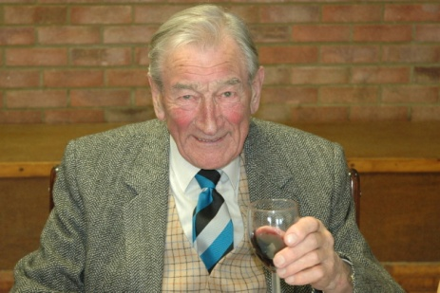Ken Young, formerly a pilot in the R.A.F. and an honorary Vice-President of the club has instilled

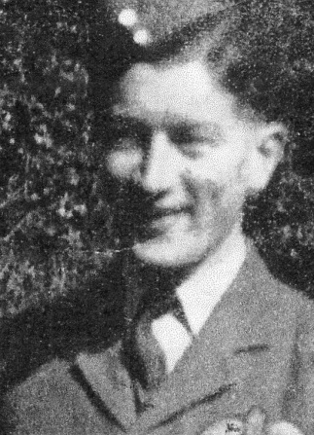much enthusiasm in Fordingbridge members for the Hampshire & Isle of Wight Air Ambulance charity. As the Chairman wrote in his article, the club takes a pride in charitable causes and nowhere is this more apparent than in the support of the Hampshire & Isle of Wight Air Ambulance.

The charity was launched in 2005 but it was two years later before the Air Ambulance became operational. The project relies entirely on voluntary donations since there is no government funding and, with increasing fuel and administration costs, the charity needs to raise around £85,000 every month to survive.

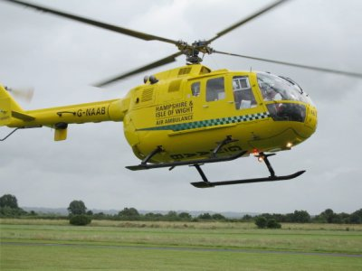None of us knows when we may need help, whether it be a road accident, a heart attack in an obscure place or even an injury on the rugby field. In fact the Hampshire Air Ambulance attended to players at Fordingbridge three times in the Anniversary season, and for this alone the charity deserves the club’s support.